Device Provisioning

Sinric Pro PaSS device provisioning sketch supports ESP8266 and ESP32 modules. We recommend ExpressIf ESP32 + 4MB chipset due to limitations in ESP8266.

Purpose of this sketch is to demonstate how to receive the credentails via the app or configure the device via AP (WebIU) and how OTA update works. You are free to make necessory changes as you wish. Make sure your changes align with our sketch so when we add new features or fixes it’s easy to integrate.

Setup IDE: Arduino

Libraries:

- Sinric Pro SDK - 2.9.16 or newer
- ESP8266 Core / ESP32 Core - v3.0.2 / ESP32 Core 2.0.1
3. WebSockets - v2.3.5
4. arduinoJson - v6.18.5
5. For ESP32: NimBLE - v1.3.7
a. Please change CONFIG_BT_NIMBLE_TASK_STACK_SIZE to 12288 in NimBLE nimconfig.h. nimconfig.h is locted in C:\Users\<>\Documents\Arduino\libraries\NimBLE-Arduino \src

On ESP32, Since we use BLE for device provisioning and have an embedded Web UI for AP configuration portal, app partition requires bit more space. So please change the Partition Scheme to “Minimal SPIFF” as below.

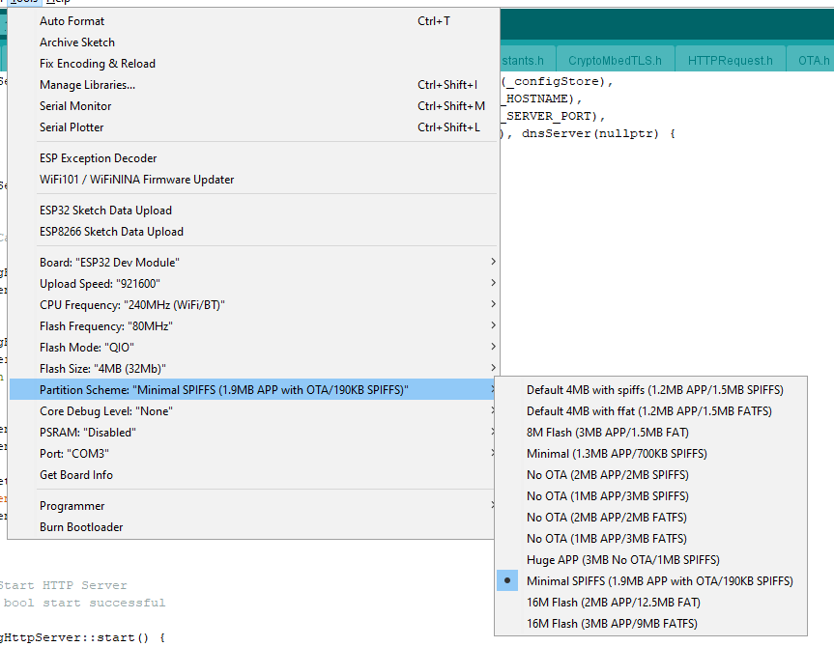

Configurations

Provisioning sketch has many features that you can turn on/off from the Settings.h

Important onces are:

- SMARTCONFIG_TIMEOUT : Wait time for SmartConfig to fall back to AP web portal configuration
- BLE_CONFIG_TIMEOUT : Wait time for BLE to fal back to AP web portal configuration
- OTA_CHECK_INTERVAL : How often the client should check for OTA updates. Minimum should be 1 day unless for testing
- ENABLE_LED_INDICATOR : If you have an LED indicator to show the provisioning status. Sketch supports single color LED, RGB LED or WS2812 RGB LED. Uncomment to enable, comment to disable
- ENABLE_RESET_BUTTON : If you have a reset button attached to the device to reset the device. Long press (5s) the button to reset, Press the button 5 times to stop the current provisioning mode and eneter AP mode provisioning.

ESP32: BLE Provisioning Flow

- The ESP device boots up
- Check whether the device has already provisioned
- If not,
  - Start BLE provisioning and wait for configurations from the app.
  - When configurations are received from the app, persist it to SPIFF and connect to server.
  - If the configurations are not received within BLE_CONFIG_TIMEOUT, Start AP (WebUI) mode provisioning. Once the devices have been saved, reset the module and connect to the server
  - If you have enabled push button, when you press 5 times, provisioning sketch will exit BLE and start AP (WebUI) mode provisioning
- Else if already provisioned, Connect to the server

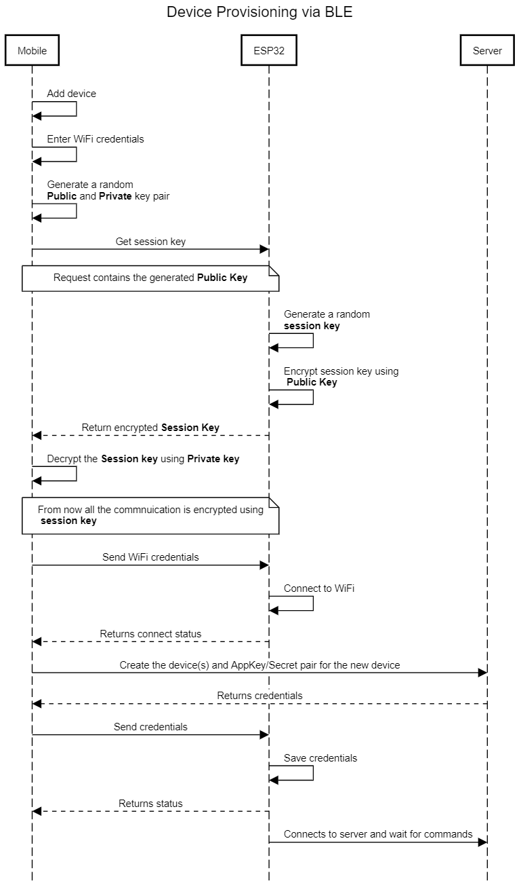

ESP8266: SmartConfig Provisioning Flow

We use SmartConfig on ESP8285/ESP8266 chipsets. SmartConfig is not perfect provisioning technique, however it’s convenient and widely adopted. Sometimes it requires to try few tries to pass the WiFi configuration to the device from App and it does not work if the phone is connected to a 5G WiFi network. Unfortunately, it’s not possible for the app to detect whether WiFi is 5G on iOS due to OS limitations.

- The ESP device boots up
- Check whether the device has already provisioned
- If not,
  - Start SmarrConfig provisioning
  - Wait until timeout (SMARTCONFIG_TIMEOUT) for WiFi SSID/Password
    - After ESP receives WiFi credentials, it starts HTTP server to receive Appkey/Secret/DeviceIds from the app.
    - Once Appkey/Secret/DeviceIds are received via app, persist them
  - If the configurations are not received, Start AP mode provisioning. Once the devices has been received, connect to the server
  - If you have enabled push button, when you press 5 times, provisioning sketch will exit SmartConfig and start AP (WebUI) mode provisioning
- If provisioned already, connect to the server.

Application requires access to Location (precision) in order to obtain the WiFi the phone is connected. Failing to grant permission will fail the provisioning process.

On Android 12 or newer devices and iOS devices, it’s required to grant Bluetooth permission as well if your device is provisioned using Bluetooth.

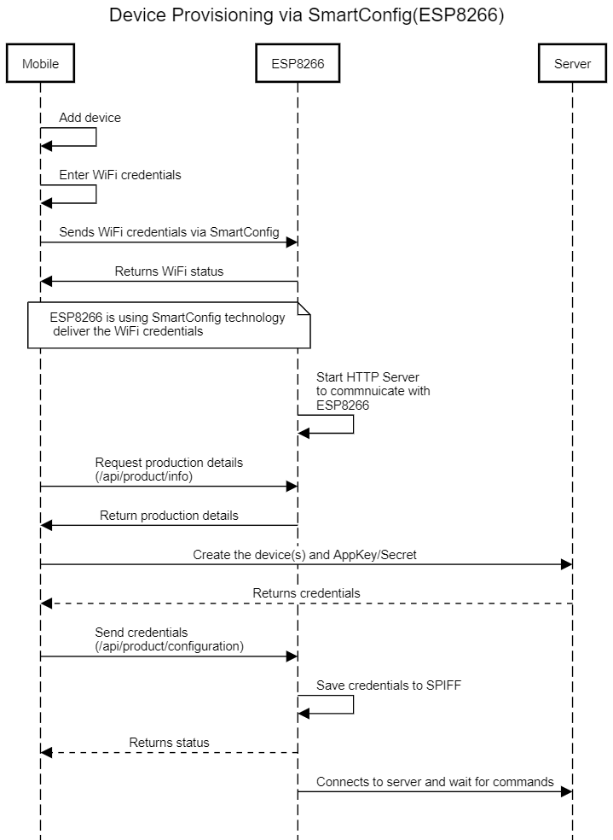

ESP8266/32: Provisioning via AP (WebUI)

After the specified timeout or if the provisioning was interruped, the progran will fall back to AP mode to configure the device. (captive portal). Using the WebUI, the users can configure the product without needing to have an app. You can use a laptop or mobile phone to connect to the AP to configure. We recommend connecting via a Laptop (Laptop seems to respond fast and convenient). SoftAP name can be configured in the sketch.

- Connect to the AP. Usually it starts with PROV-xxx (xxx = MAC address)

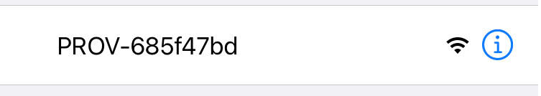

- Once you connect to AP, Web browser will automatically open the configuration portal. If you are connecting to a ESP8266, this may takes few seconds to open. If not, open http://192.168.4.1 (STATIC_IP) in your browser.

- Select the WiFi and enter the password. ESP scans for list of WiFis near the module. If your WiFi is not present in the list, move close to the ESP or hit “refresh”

- Next, You can let the “Auto” option to configure the device for you or use the “Manual” option to configure the device manually.

  - Auto
    - If you select Auto option, the system requires to enter an email address and the password and click “Auto Configure”. If the user email does not exisit in the server, then the server creates a user account for the emai/password entered. Otherwise use the specified email address. During the setup, server will use default names (can be configured) and configure the device and let the user know the device has been configured.
  - Manual
    - If you select “Manual” option, the user has the ability to create a new account/use existing account, room and set the device name/description during the setup

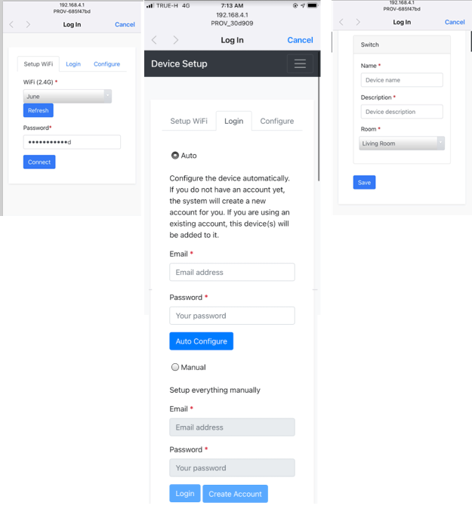

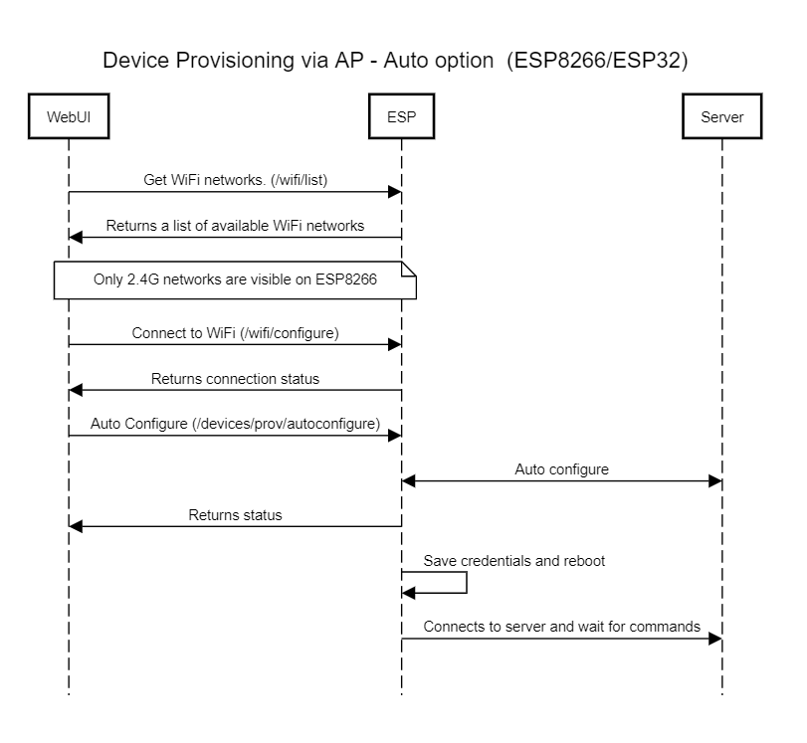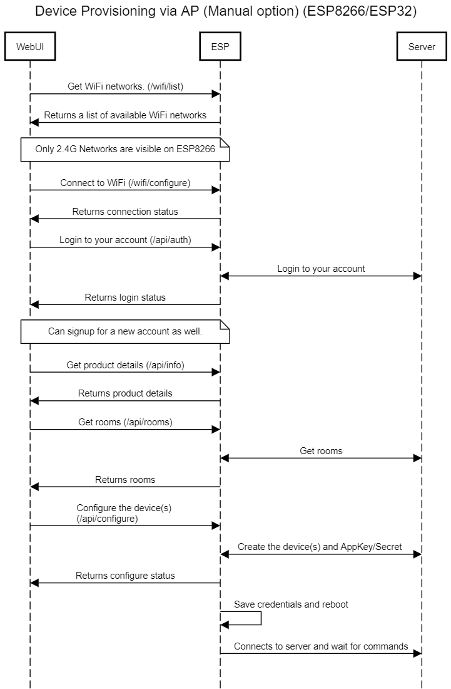

OTA Updates

OTA updates are available via Admin UI.

1. Change the firmware version in the sketch. FIRMWARE_VERSION in Settings.h
2. Arduino IDE -> Sketch -> Export compiled Binary
3. Go to Admin Panel. -> OTA Updates -> New OTA Update
4. Enter
4.1 Version: xx.xx.xx,
4.2 MAC Address: leave empty if this update is available for all devices. If you specify a MAC Address then this update is only available to the device with the specified MAC address
4.3 Browse the generated OTA file from step 3
4.4 Click Save

ESP checks for updates defined in OTA_CHECK_INTERVAL in Settings.h file. By default it’s set to 1 day. Do not change this to lower unless for it’s testing.

OTA and Security

In order to download an OTA update from the server, the ESP must answer to a challenge by the server and prove itself that it’s an authorized device (CRAM authentication) to download the update and install in order to prevent people from loading custom firmware.

We recommend you sign the firmware as per ExpressIf documentation add additional protection.

https://arduino-esp8266.readthedocs.io/en/latest/ota_updates/readme.html#signed-binary-prerequisites

FAQ

- How to compile index.html.gz.h / How to change AP HTML Code

index.html.gz.h is a header file which consist of complete HTML + CSS + JS code. We noticed serving the file from PROGMEM is faster and reliable and makes no mistakes.

If you wish to make any changes to AP HTML code

- Install NodeJS
- Run: npm install
  - This command will install the dependencies
- Run: npm install --global gulp-cli
- Make the changes
- Run: gulp
  - Once you run gulp command, it will combine all the files and generate index.html.gz.h in /preprocessed folder. Copy this to source folder

How to report issues

Please do not send generic messages like “it does not work”. These are not helpful to identify and fix. We need steps to produce any issues you encounter during testing.

      - Enable SDK logs

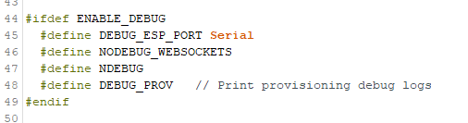

This would print Sinric Pro SDK logs to Serial Monitor.

      - Enable ESP SDK Core Logs (ESP32)

For ESP32:
Tools -> Core Debug Level -> Verbose
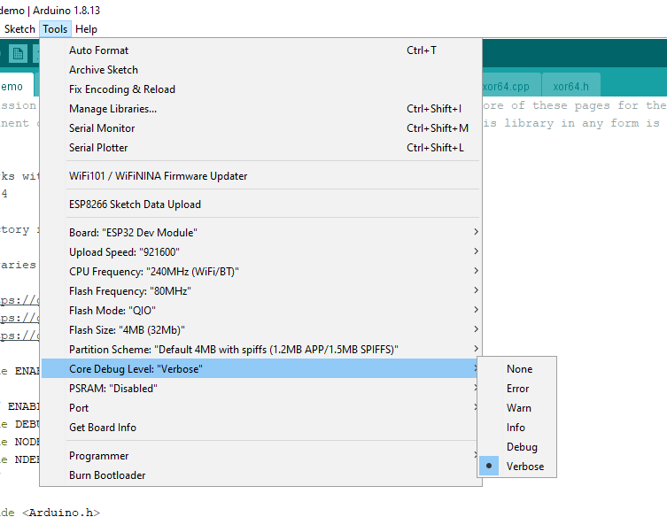

For ESP8266
Tools -> Debug Serial Port -> Serial
-> Debug Level -> HTTP_CLIENT ** for AP issues
-> Debug Level -> HTTP_UPDATE ** for OTA update issues
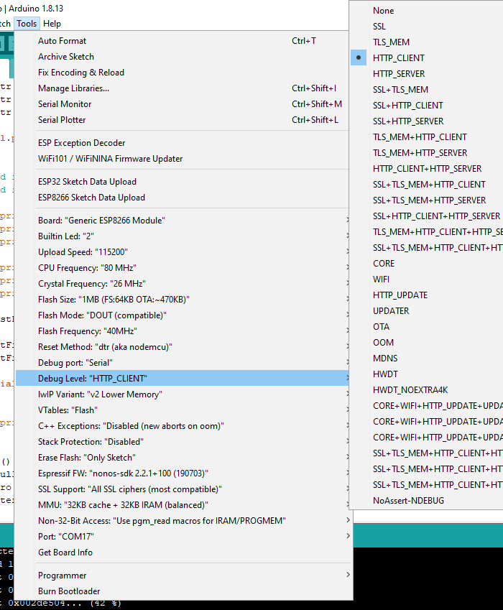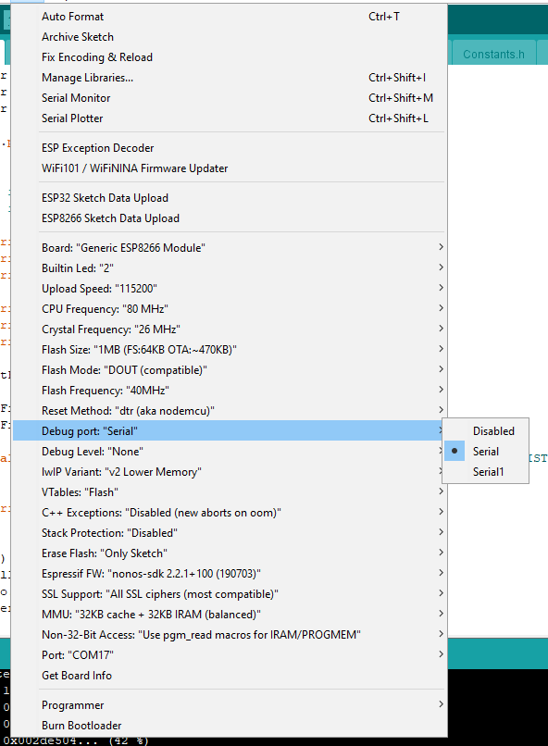

Collect the above two and drop an email to support@sinric.com

